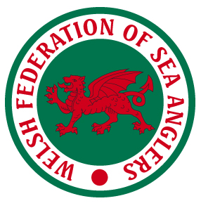
Welsh Federation of Sea Anglers
Welsh Record Claim Form
Please complete in full using BLOCK CAPITALS

Name
Address

Post Code

Club PM
Email Address
Species
Weight Kilo’s Grams
lbs Oz
Length CM Girth
inches Girth
Where Caught
Date of Capture
Boat/Shore Port (if Boat)
Please select award Category Age if Junior
There should be at least one witness to the capture & weighing to support any WFSA claim. Claims must be supported by numerous photographs from all angles. If there are no witnesses to capture the claimant must verify their claim by affidavit. Claims must be received within 2 weeks of the date of capture. Fish do NOT need to be killed in order to claim a Welsh Record. Fish must be weighed on Certified Scales.
Witness to Capture Witness to Weighing
Name Name
Address Address

Phone No Phone No

Witness to Capture Witness to Weighing
Name Name
Address Address

Phone No Phone No

I declaire that I have caught the fish as described in my claim and that it was caught by fair rod and line angling in the waters of the Principality of Wales (please insert a scanned image of your signature or type your name and check the box to confirm information above is a true account).
Claimants Signature ☐

All claims for a Welsh Record (rod caught) sea fish must be sent to:

The General Secretary, Mrs Helen Pearce, 9 Maes Afallen, Bow Street, Aberystwyth, Ceredigion, SY24 5BL. Email: secretary@wfsa.org.uk

Please send or email a photo for inclusion on the WFSA website and Facebook page.

Awards will be decided at the National Executive Committee Meetings and will be announced on the WFSA website and Facebook page. All award winners will be notified by email or letter

